John McCormack  
Assignment #2  
2/17/2015

histogram.py

This program opens four copies of the same image, each with a slightly different edit to it. It then computes the CDF of each image, and normalizes the image based on this. The system works perfectly for the Low Contrast, Dark, and Bright images. On the High contrast image, the histogram has trouble correcting the skyline of the image. This may be an issue with using Gimp, as the image itself seems distorted after increasing the contrast. The CDFs are all plotted on the same graph. Each of the histograms are also independently graphed along with their CDFs in separate files.

The original image is:



Low Contrast:



High Contrast:

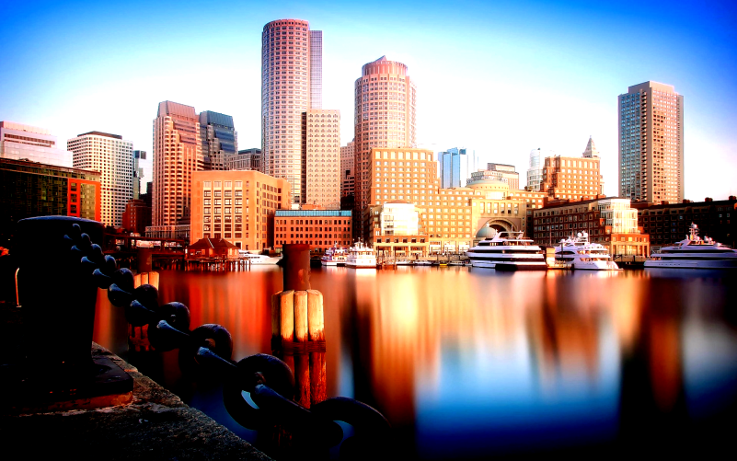

Dark:



Bright:



Output Image:

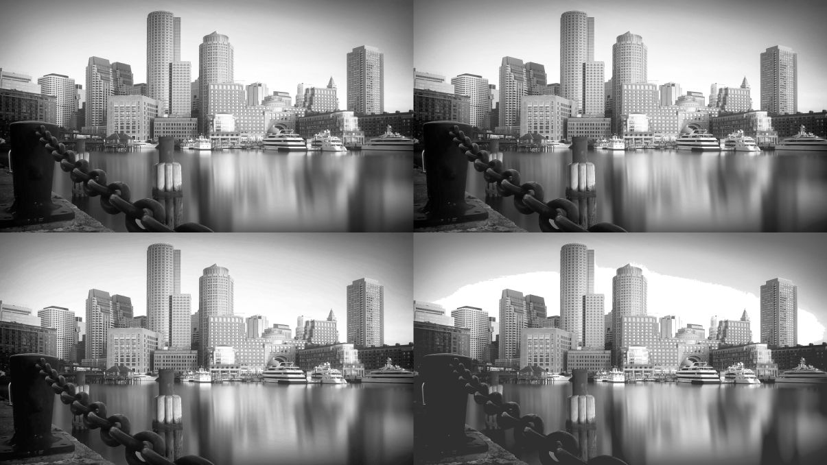

Top Right: Bright  
Top Left: Dark  
Bottom Right: Low Contrast  
Bottom Left: High Contrast

CDFs of all functions:

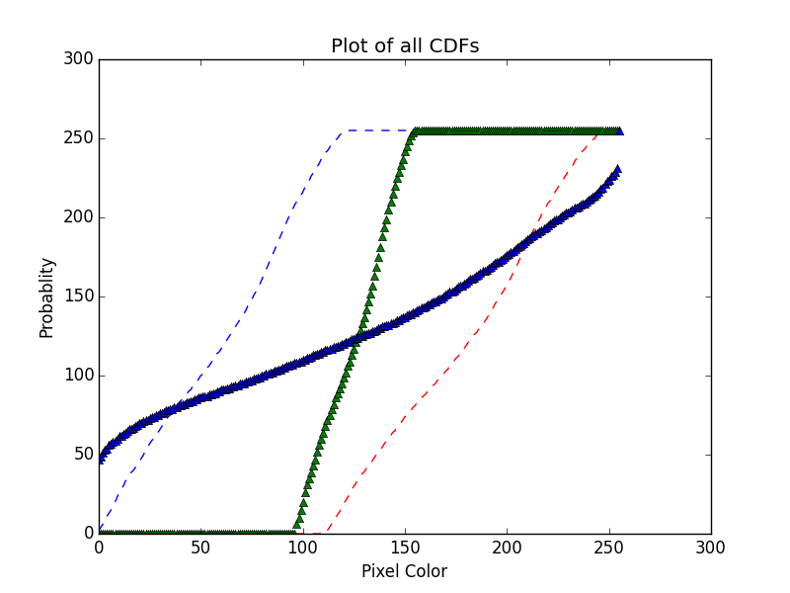

Green Triangle = High Contrast  
Blue Triangle = Low Contrast  
Blue Dash = Dark  
Red Dash = Bright

Histograms:

Bright

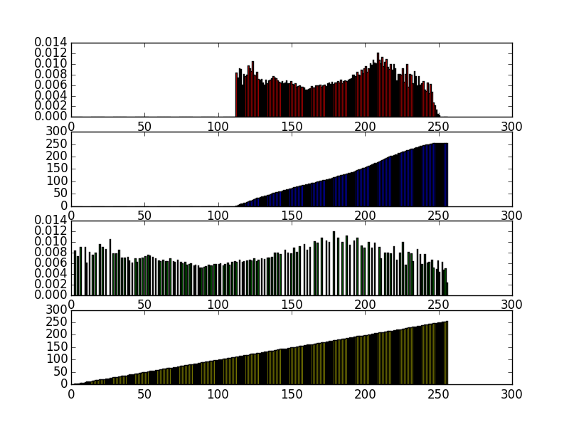

The bright image had a all of its information in the upper bands. After the transformation they spread out across the bands. The CDF stayed at 0 for much of the chart, corresponding to the lack of dark color information.

Dark

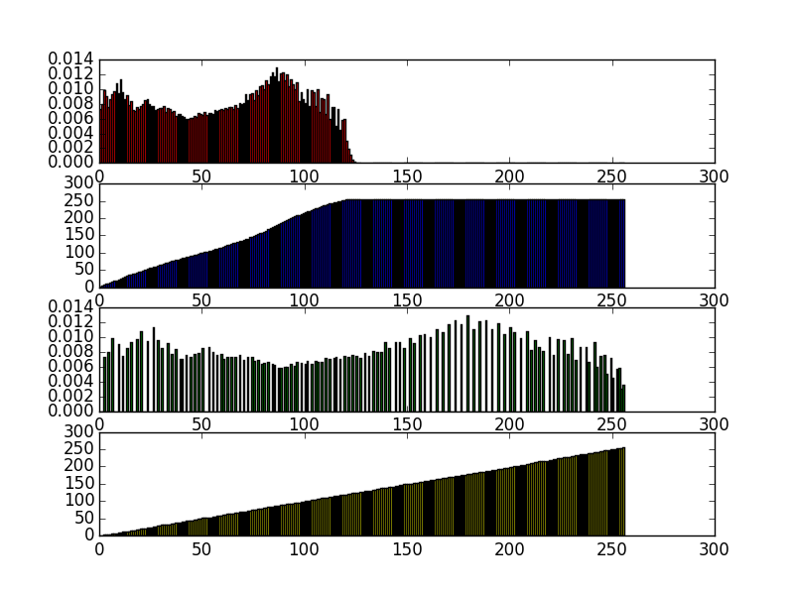

The dark was the opposite of the bright, the information was only in the lower portion of the spectrum. The CDF rose quickly to full. Again, after the transformation, the information spreads out.

High Contrast:

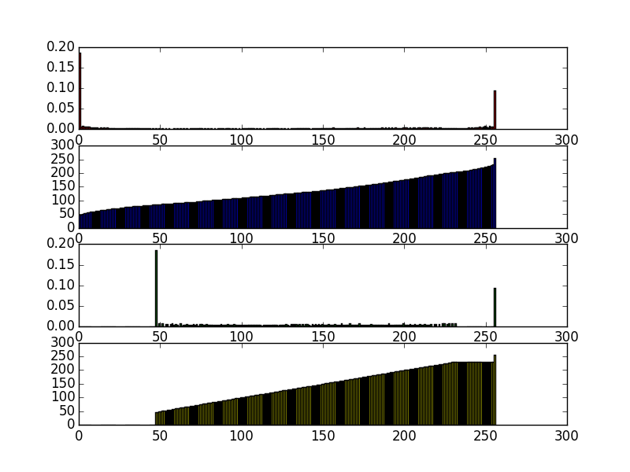

The pixels were primarily at either end of the spectrum. The transformation was less effective on this image than on any of the other ones.

Low Contrast:

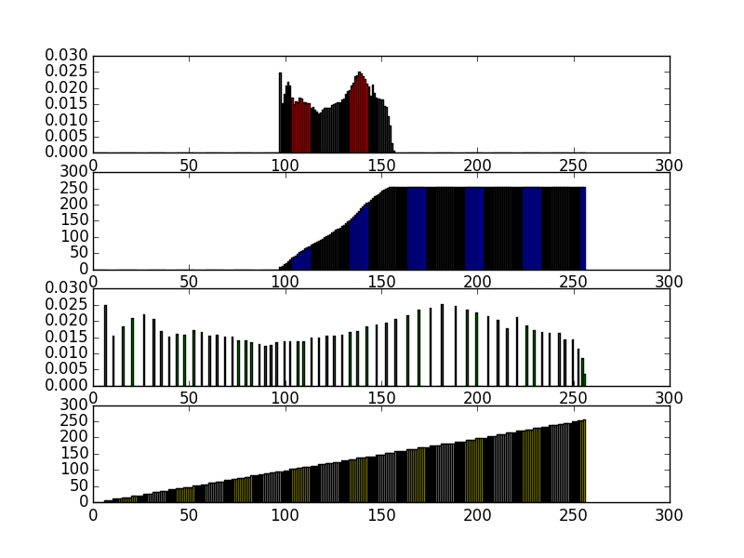

The chart was densely centered around the center bands. After the transformation the parts of the graph were dramatically spaced out.